| **Project Title** | **Local Food Wastage Management System** |
| --- | --- |
| **Skills take away From This Project** | * Python * SQL * Streamlit * Data Analysis |
| **Domain** | * Food Management * Waste Reduction * Social Good. |

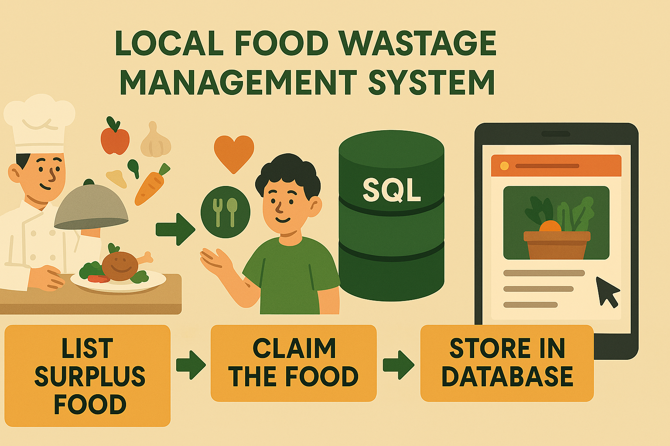

**Problem Statement**

Food wastage is a significant issue, with many households and restaurants discarding surplus food while numerous people struggle with food insecurity. This project aims to develop a Local Food Wastage Management System, where:

* Restaurants and individuals can list surplus food.
* NGOs or individuals in need can claim the food.
* SQL stores available food details and locations.
* A Streamlit app enables interaction, filtering, CRUD operation and visualization.

**Business Use Cases**

* **Connecting surplus food providers** to those in need through a structured platform.
* **Reducing food waste** by redistributing excess food efficiently.
* **Enhancing accessibility** via geolocation features to locate food easily.
* **Data analysis** on food wastage trends for better decision-making.

**Approach**

### **Data Preparation**

* Utilize a **provided dataset** containing food donation records.
* Ensure consistency and accuracy in data formatting.

### **2. Database Creation**

* Store food availability data in **SQL tables**.
* Implement **CRUD operations** for updating, adding, and removing records.

### **3. Data Analysis.**

* Identify **food wastage trends** based on categories, locations, and expiry dates.
* Generate reports for effective food distribution.

### **4. Application Development**

Develop a **Streamlit-based user interface** to:

* Display output of the **15 SQL queries** .
* Provide **filtering options** based on city, provider, food type, and meal type.
* Show **contact details** of providers for direct coordination.

### **5. Deployment**

* Deploy the **Streamlit** application for accessibility and real-time interaction

**Data Flow and Architecture**

### **Data Storage:**

* Use **SQL database** to store food donations, locations, and provider details.

### **Processing Pipeline:**

* Do analysis and generate insights into food wastage patterns.

### **Deployment:**

* Develop a **Streamlit-based interface** for food providers and seekers.

**Dataset**

1. **Providers Dataset :** [**providers_data.csv**](https://drive.google.com/file/d/1nYaJUVwb9WzDiWlW15rfiIDCELYImx__/view?usp=sharing)
2. **Receivers Dataset:** [**receivers_data.csv**](https://drive.google.com/file/d/1hw330IEaPUl7N9Jcm3IsyFoX8Ti5PyS6/view?usp=sharing)
3. **Food Listings Dataset:** [**food_listings_data.csv**](https://drive.google.com/file/d/1hZ7w3YtNQqFRmfzV6sQ8QfCXVGnlei_m/view?usp=drive_link)
4. **Claims Dataset:** [**claims_data.csv**](https://drive.google.com/file/d/1G-qlvSwaiVo-8cSxCbSoXBNYL2OYUN6x/view?usp=drive_link)

**Dataset Description**

### **1. Providers Dataset**

The **providers.csv** file contains details of food providers who contribute surplus food to the system.

* **Provider_ID** (Integer) – Unique identifier for each provider.
* **Name** (String) – Name of the food provider (e.g., restaurants, grocery stores, supermarkets).
* **Type** (String) – Category of provider (e.g., Restaurant, Grocery Store, Supermarket).
* **Address** (String) – Physical address of the provider.
* **City** (String) – City where the provider is located.
* **Contact** (String) – Contact information (e.g., phone number).

### **2. Receivers Dataset**

The **receivers.csv** file contains details of individuals or organizations receiving food.

* **Receiver_ID** (Integer) – Unique identifier for each receiver.
* **Name** (String) – Name of the receiver (individual or organization).
* **Type** (String) – Category of receiver (e.g., NGO, Community Center, Individual).
* **City** (String) – City where the receiver is located.
* **Contact** (String) – Contact details (e.g., phone number).

### **3. Food Listings Dataset**

The **food_listings.csv** file stores details of available food items that can be claimed by receivers.

* **Food_ID** (Integer) – Unique identifier for each food item.
* **Food_Name** (String) – Name of the food item.
* **Quantity** (Integer) – Quantity available for distribution.
* **Expiry_Date** (Date) – Expiry date of the food item.
* **Provider_ID** (Integer) – Reference to the provider offering the food.
* **Provider_Type** (String) – Type of provider offering the food.
* **Location** (String) – City where the food is available.
* **Food_Type** (String) – Category of food (e.g., Vegetarian, Non-Vegetarian, Vegan).
* **Meal_Type** (String) – Type of meal (e.g., Breakfast, Lunch, Dinner, Snacks).

### **4. Claims Dataset**

The **claims.csv** file tracks food claims made by receivers.

* **Claim_ID** (Integer) – Unique identifier for each claim.
* **Food_ID** (Integer) – Reference to the food item being claimed.
* **Receiver_ID** (Integer) – Reference to the receiver claiming the food.
* **Status** (String) – Current status of the claim (e.g., Pending, Completed, Cancelled).
* **Timestamp** (Datetime) – Date and time when the claim was made.

## **Questions to be Answered (SQL Queries & Analysis)**

The project will analyze food donations, claims, and provider trends using SQL queries. Below are some key questions:

### **Food Providers & Receivers**

1. How many food providers and receivers are there in each city?
2. Which type of food provider (restaurant, grocery store, etc.) contributes the most food?
3. What is the contact information of food providers in a specific city?
4. Which receivers have claimed the most food?

### **Food Listings & Availability**

1. What is the total quantity of food available from all providers?
2. Which city has the highest number of food listings?
3. What are the most commonly available food types?

### **Claims & Distribution**

8. How many food claims have been made for each food item?

9. Which provider has had the highest number of successful food claims?

10. What percentage of food claims are completed vs. pending vs. canceled?

### **Analysis & Insights**

11. What is the average quantity of food claimed per receiver?

12. Which meal type (breakfast, lunch, dinner, snacks) is claimed the most?

1. What is the total quantity of food donated by each provider?

**Results**

✅ A fully functional **Streamlit app** that allows users to:

* **Filter food donations** based on location, provider, and food type.
* **Contact food providers and receivers** directly through the app.
* Implement **CRUD operations** for updating, adding, and removing records.
* **All the 15 queries** along with their outputs.

✅ **SQL-powered analysis** that provides insights into:

* **The most frequent food providers** and their contributions.
* **The highest demand locations** based on food claims.
* **Trends in food wastage** to improve distribution efforts.
* All the 15 queries along with their outputs.

**Project Evaluation Metrics**

* Completeness of SQL database with all necessary food donation records.
* Accuracy of SQL queries in analyzing food donation trends.
* Functionality of CRUD operations for food listing and claims.
* User-friendliness of the Streamlit interface..

**Technical Tags:**

Python, SQL, Streamlit, Data Analysis, Food Management

**Deliverables:**

### **Data Preparation:**

* Store and clean the provided dataset.

### **SQL Queries for Analysis:**

* Execute **15+ queries** for trend analysis and reporting.

### **Application Development:**

* Develop a **Streamlit interface** to display results and predictions, including EDA.

**Timeline:**

To be defined based on the project’s milestones and submission deadlines.

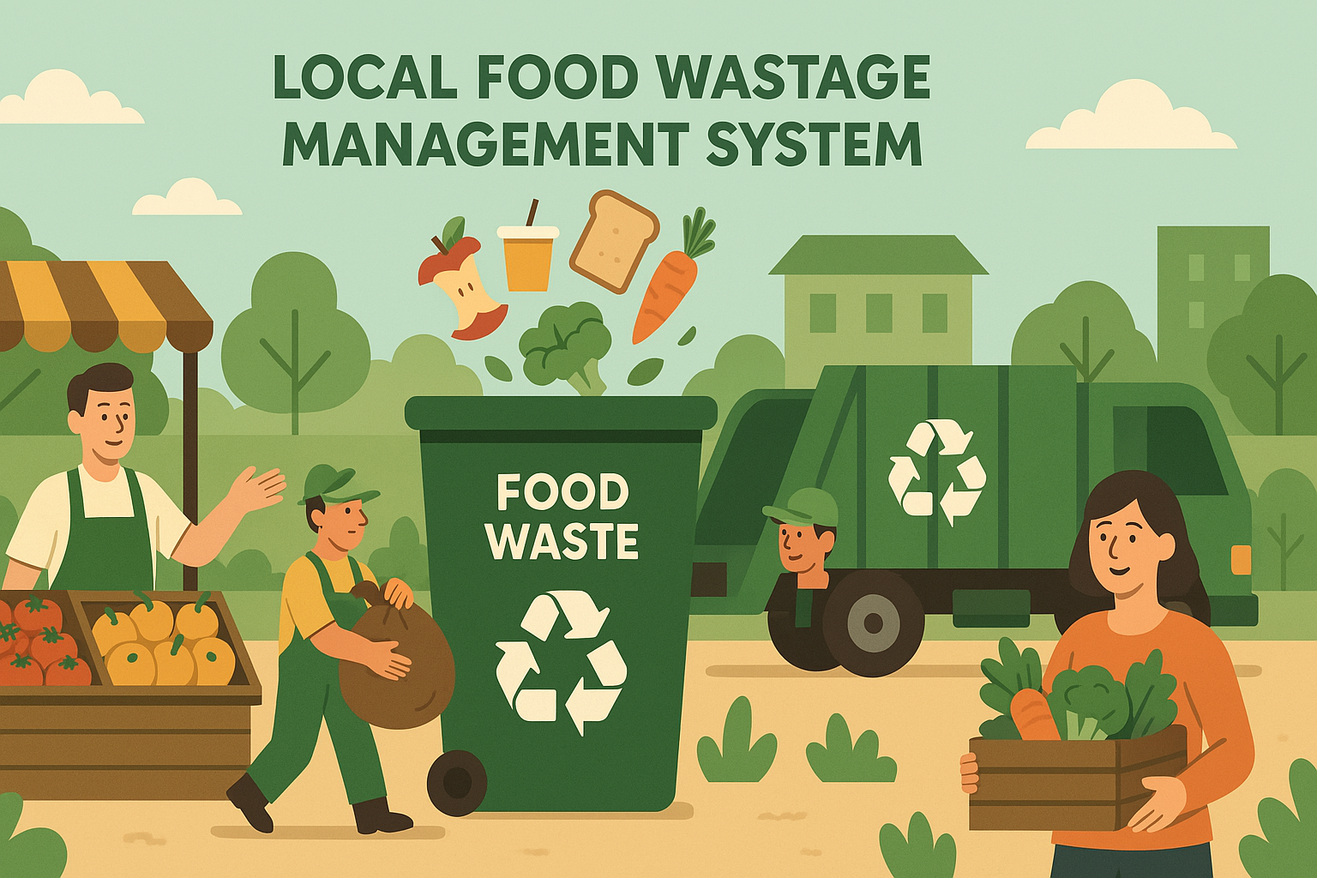

**References:**

| Project Live Evaluation Metrics | [Project Live Evaluation](https://docs.google.com/document/u/0/d/1QisLD2kqDWFZJG2oDknKn2eMGi-Xq8oFPgA7UWSbcIQ/edit) |
| --- | --- |
| EDA Guide | [Exploratory Data Analysis (EDA) Guide](https://docs.google.com/document/d/1tHiTU1X9UwXSLySpJ-FVCohlf_8xpXwa75vlK9S6wl8/edit?usp=sharing) |
| Capstone Explanation Guideline | [Capstone Explanation Guideline](https://docs.google.com/document/d/1gbhLvJYY7J73lu1g9c6C9LRJvYemiDOdRDAEMe632w8/edit) |
| GitHub Reference | [How to Use GitHub.pptx](https://docs.google.com/presentation/d/1XHCbgUOqbcXNUyQ87vTlKdKRgAbBxtkA/edit?usp=sharing&ouid=109735616107417446342&rtpof=true&sd=true) |
| Streamlit recordings (English) | [Special session for STREAMLIT(11/08/2024)](https://docs.google.com/document/d/1aR3pUZFlCi8gicpF6aPHPESeFdOtGMlfob5PckresZk/edit?usp=sharing) |
| Streamlit recordings (Tamil) |  |
| Streamlit documentation | [Install Streamlit](https://docs.streamlit.io/get-started/installation) |
| HOW TO ESTABLISH SQL CONNECTION | [PYTHONSQLCODE_TAMIL.ipynb](https://drive.google.com/file/d/1ZdgP0OgpxamIKJzAPspZkrExD0JvZb-A/view?usp=sharing) |
| Project Orientation (English) | [Project Orientation Session : Local Food Wastage Management System(English))](https://docs.google.com/document/d/10GpqpCYn9mpzcCojix4CH6vanVzIwMybSqfMSVp2V_M/edit?usp=sharing)  [Project Orientation Session : Local Food Wastage Management System (English)](https://docs.google.com/document/d/1FxlPuxT07j8q6PTk7ZsAIBU3B1kYqql4qmoB8J_h3Ng/edit?usp=sharing) |
| Project Orientation (English)(Classify link) | <https://classify.zenclass.in/meet-video?session=6ed623fe-45be-4d90-86ca-1b4f75fd4e7a&index=0> |
| Project Orientation (Tamil) |  |
| Project Orientation(Hindi) |  |
| Colab file | [food.ipynb](https://drive.google.com/file/d/1n8PQ_9X9jirjFLfqfzhqM04QE8MHSBRy/view?usp=sharing) |
| Project Excellence Series (English) | [Project Excellence Series: Guided Learning & Problem Solving [Python & SQL](English)](https://docs.google.com/document/d/1hj9s5C9mylUEQR7E9kcfuKyICr3sQ9T7YDuE3LnRZYQ/edit?usp=sharing) |
| Project Excellence Series (Tamil) | [Project Excellence Series: Guided Learning & Problem Solving [Python & SQL](Tamil)](https://docs.google.com/document/d/1MiStEEh6KHpoCvdpD0yTtNpphEbp02j4SVbQrGBQqx8/edit?usp=sharing) |

PROJECT DOUBT CLARIFICATION SESSION ( PROJECT AND CLASS DOUBTS)

About Session: The Project Doubt Clarification Session is a helpful resource for resolving questions and concerns about projects and class topics. It provides support in understanding project requirements, addressing code issues, and clarifying class concepts. The session aims to enhance comprehension and provide guidance to overcome challenges effectively.

Note: Book the slot at least before 12:00 Pm on the same day

Timing: Monday-Saturday (4:00PM to 5:00PM) (Except Second Saturday)

Booking link :<https://forms.gle/XC553oSbMJ2Gcfug9>

LIVE EVALUATION SESSION (CAPSTONE AND FINAL PROJECT)

About Session: The Live Evaluation Session for Capstone and Final Projects allows participants to showcase their projects and receive real-time feedback for improvement. It assesses project quality and provides an opportunity for discussion and evaluation.

Note: This form will Open only on Saturday (after 2 PM ) and Sunday on Every Week

Timing:

For DS and AIML

Monday-Saturday (05:30PM to 07:00PM)

Booking link : <https://forms.gle/1m2Gsro41fLtZurRA>

Evaluation Metrics : [Project Live Evaluation](https://docs.google.com/document/d/1QisLD2kqDWFZJG2oDknKn2eMGi-Xq8oFPgA7UWSbcIQ/edit?usp=sharing)

| Project Created By | Verified By | Approved By |
| --- | --- | --- |
| Vinodhini | [Nehlath Harmain](mailto:nehlath@guvi.in) | [**Nehlath Harmain**](mailto:nehlath@guvi.in) |